Quiz 2 Chapter 3 #1

Class Name : *MT* Math 095 MW Fall 18 - Math 095 MW Fall18 B02
Instructor Name : Bottom

Student Name : _____________________ Instructor Note :
- For each ordered pair, determine whether it is a solution to y = 6 x − 4.
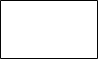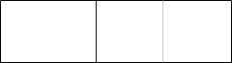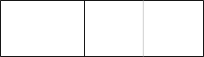
Is it a solution?
x , y
Yes
No
− 6, 27
− 4, − 9
3, − 14
8, 44

- Graph the line.
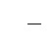
3
y = 2 x
6
4
x
-2
-8
-6
-4
8
6
4
2
2
-
4
-
6
-
8
-
2
8
y

- Graph the line.

y = 2 x − 7
6
4
x
-2
-8
-6
-4
8
6
4
2
2
-
4
-
6
-
8
-
2
8
y

- Graph the line y = −1.
6
4
x
-2
-8
-6
-4
8
6
4
2
2
-
4
-
6
-
8
-
2
8
y

- Find the x-intercept and the y-intercept of the line below.

6
5
4
3
2
x
1
-1
-2
-3
-4
-5
-6
6
5
4
3
2
1
2 -
3 -
-
-4
-5
-6
1
y
x- intercept = (4,0)

y- intercept = (0,3)

- Find the x-intercept and y-intercept of the line.

6 x + 5 y = −12
x-intercept: __(-2,0)_____________
y-intercept: ____(0,-2.4)___________

- The equation of a line is given below.

6 x − 9 y = 27

Find the x-intercept and the y-intercept. Then use them to graph the line.

x-intercept: __(4.5,0)_____________
y-intercept: ___(0,-3)____________
y
8
6
4
2
x
-8 -6 -4 -2
2
4
6
8
-2
-4
-6
-8

- 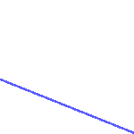For each line, determine whether the slope is positive, negative, zero, or undefined.
y
x

_ Positive
_ Negative
_ Zero
_ Undefined

_ Positive
y
x
_ Negative
_ Zero
_ Undefined

_ Positive
y
x
_ Negative
_ Zero
_ Undefined

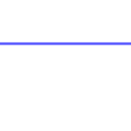_ Positive
y
x
_ Negative
_ Zero
_ Undefined

- Fill in the blanks below.

Find the slope of the line passing through the points −8, 5 and 8, 5 .
slope: 0
Find the slope of the line passing through the points 9, −2 and −2, −2 .
slope: 0

- Graph the line with slope passing through the point .
1
2
4, 2

½ = (y – 2)/(x-4)
2(y-2) = x – 4
2y -4 = x – 4
2y = x
y = x/2

10
y
8
6
4
2
x
-10 -8 -6 -4 -2
2 4 6 8 10
-2
-4
-6
-8
-10

- Find the y-intercept and the slope of the line.
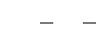
y = − 5 x − 2
1
1
x- intercept = (-2.5,0)

y- intercept = (0,-0.5)

- Find the y-intercept and the slope of the line.

−2 x + 5 y = −4
5y = 2x -4
y = 2x/5 – 4/5
Slope = 2/5 or 0.4
y-intercept = (0, 4/5) or (0, 0.8)

Write your answers in simplest form.

- A line passes through the point and has a slope of 5.
−3, −6

Write an equation in slope-intercept form for this line.

5/1 = (y +6)/(x+4)
(y+6) = 5(x +4)
y +6 = 5x + 20
y = 5x + 20 - 5
y = 5x + 15

- 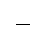Write an equation in slope-intercept form for the line with slope and y-intercept 7.
1
− 2

y = -x/2 + 7

- The equations of three lines are given below.

Line 1:

Line 2:

Line 3:
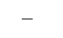
1
y = 3 x − 7

3 x + 9 y = −9
y = −3 x + 6

For each pair of lines, determine whether they are parallel, perpendicular, or neither.
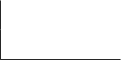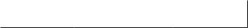

Line 1 and Line 2: | Parallel | Perpendicular | Neither
Line 1 and Line 3: | Parallel | Perpendicular | Neither
Line 2 and Line 3: | Parallel | Perpendicular | Neither

1
- Consider the line y = 3 x.
What is the slope of a line perpendicular to this line? Slope = -3
What is the slope of a line parallel to this line? Slope = 1/3
- Consider the line 8x + 4 y = 3.
8x + 4 y = 3
4y = -8x + 3
y = -2x + ¾
What is the slope of a line parallel to this line?
Slope = -2

What is the slope of a line perpendicular to this line?

Slope = ½
- A line passes through the point and has a slope of 3.
−4, 2

Write an equation in point-slope form for this line.

3/1 = (y - 2)/(x+4)
(y- 2) = 3(x +4)
y - 2 = 3x + 12
y = 3x + 12 + 2
y = 3x + 14

- A line passes through the point and has a slope of .
10, 2
1
2

Write an equation in slope-intercept form for this line.

1/2 = (y - 2)/(x - 10)
2(y- 2) = (x - 10)
2y - 4 = x - 10
2y = x -10 + 4
y = x/2 - 6

- Find an equation for the line below.
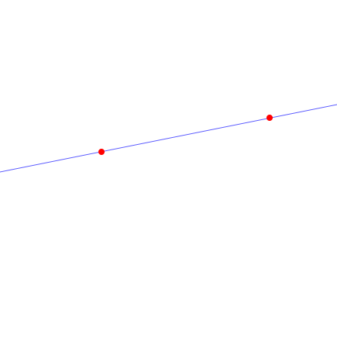
8
4
x
-4
-8
-6
-2
8
6
4
2
2
-
-4
6
-
-8
2
6
y
(-1,1) (6,3)

Slope = (3 - 1)/(6 +1) = 2/7

2/7 = (y - 1)/(x+1)
7(y- 1) = 2(x +1)
7y - 7 = 2x + 2
7y = 2x + 2 + 7
7y = 2x + 9
y = 2x/7 + 9/7

Quiz 2 Chapter 3 #1 Answers for class *MT* Math 095 MW Fall 18 - Math 095 MW Fall18 B02
1.
Is it a solution?
x , y
Yes
No
− 6, 27
− 4, − 9
3, − 14
8, 44

2.
y
8
6
(4, 6)
4
(2, 3)
2
x
-8 -6 -4 -2
(0, 0)
2 4 6 8
-2
-4
-6
-8

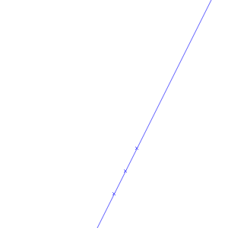3.
y
8
6
4
2
x
-8 -6 -4 -2
2 4 6 8
-2
(2, -3)
-4
(1, -5)
-6
(0, -7)
-8

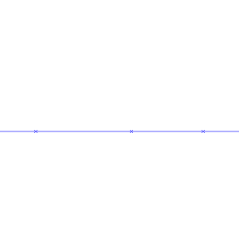4.
y
8
6
4
2
x
-8 -6 -4 -2
2 4 6 8
-2
-4
-6
-8
- x-intercept: 4
y-intercept: 3

- 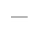x-intercept: −2
12
− 5
y-intercept:

9
- x-intercept: 2
y-intercept: −3
y
8
6
4
2
x
-8 -6 -4 -2
2
4
6
8
-2
-4
-6
-8

8.

_ Positive x Negative
y
x
_ Zero
_ Undefined

_ Positive
y
x
_ Negative
_ Zero
x Undefined

_ Positive x Negative
y
x
_ Zero
_ Undefined

_ Positive
y
x
_ Negative x Zero
_ Undefined

9.
Find the slope of the line passing through the points −8, 5 and 8, 5 .
slope: 0
Find the slope of the line passing through the points 9, −2 and −2, −2 .
slope: 0

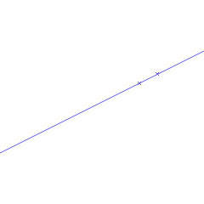10.
10 y
8
6
4
2
(6, 3)
(4, 2)
x
-10 -8 -6 -4 -2
2 4 6 8 10
-2
-4
-6
-8
-10

- y-intercept: slope:
1
− 2
1
− 5

- y-intercept: slope:
4
− 5
2
5
13. y = 5 x + 9

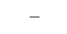14.
1
y = − 2 x + 7

15.

Line 1 and Line 2: | Parallel | Perpendicular | Neither
Line 1 and Line 3: | Parallel | Perpendicular | Neither
Line 2 and Line 3: | Parallel | Perpendicular | Neither

16.
Slope of a perpendicular line: −3

Slope of a parallel line:
1
3

17.
Slope of a parallel line: −2
1
2

Slope of a perpendicular line:

18.
y − 2 = 3 x + 4

19.
1
y = 2 x − 3

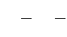20.
y = 5 x + 5
1
9

